**Ex. No. : 8b Date: 28/04/2025**

**Register No.: 221701050 Name: D Sathiya Sri**



**Send Email**

**Aim**

Develop an application to send Email.

***Procedure:***

1. Create a New Android Project  
   * Open Android Studio and create a new project with Empty Activity.
   * Choose Kotlin as the programming language.
2. Design the Layout (activity_main.xml)  
   * Add EditText fields for entering the recipient's email, subject, and message.
   * Add a Button to trigger the email sending action.
3. Set Up Email Intent  
   * Use an Intent with ACTION_SEND to send an email through an email client (like Gmail).
4. Prepare Email Content  
   * Collect the email address, subject, and message entered by the user.
5. Launch Email Client  
   * Set up the email Intent to include the recipient's email, subject, and message, and launch the email client.
6. Handle Email Sending  
   * Use an OnClickListener to trigger the email sending action when the user clicks the Send Email button.
7. Run and Test the Application  
   * Build and run the app on a device to test the email sending functionality.

***AndroidManifest.xml***

<?xml version="1.0" encoding="utf-8"?>

<manifest xmlns:android="http://schemas.android.com/apk/res/android"

xmlns:tools="http://schemas.android.com/tools">

<application

android:allowBackup="true"

android:dataExtractionRules="@xml/data_extraction_rules"

android:fullBackupContent="@xml/backup_rules"

android:icon="@mipmap/ic_launcher"

android:label="@string/app_name"

android:roundIcon="@mipmap/ic_launcher_round"

android:supportsRtl="true"

android:theme="@style/Theme.Exp8b"

tools:targetApi="31">

<activity

android:name=".MainActivity"

android:exported="true">

<intent-filter>

<action android:name="android.intent.action.MAIN" />

<category android:name="android.intent.category.LAUNCHER" />

</intent-filter>

</activity>

</application>

</manifest>

***Activity_main.xml***

<?xml version="1.0" encoding="utf-8"?>

<LinearLayout xmlns:android="http://schemas.android.com/apk/res/android"

android:layout_width="match_parent"

android:layout_height="match_parent"

android:orientation="vertical"

android:padding="24dp">

<EditText

android:id="@+id/editTextRecipient"

android:hint="Recipient Email"

android:layout_width="match_parent"

android:layout_height="wrap_content"

android:inputType="textEmailAddress" />

<EditText

android:id="@+id/editTextSubject"

android:hint="Subject"

android:layout_width="match_parent"

android:layout_height="wrap_content"

android:layout_marginTop="12dp" />

<EditText

android:id="@+id/editTextMessage"

android:hint="Message"

android:layout_width="match_parent"

android:layout_height="wrap_content"

android:layout_marginTop="12dp"

android:minLines="4"

android:gravity="top"

android:inputType="textMultiLine" />

<Button

android:id="@+id/buttonSend"

android:text="Send Email"

android:layout_width="match_parent"

android:layout_height="wrap_content"

android:layout_marginTop="20dp" />

</LinearLayout>

***MainActivity.kt***

package com.example.exp_8b

import android.content.Intent

import android.net.Uri

import android.os.Bundle

import android.widget.Button

import android.widget.EditText

import android.widget.Toast

import androidx.appcompat.app.AppCompatActivity

class MainActivity : AppCompatActivity() {

private lateinit var editTextRecipient: EditText

private lateinit var editTextSubject: EditText

private lateinit var editTextMessage: EditText

private lateinit var buttonSend: Button

override fun onCreate(savedInstanceState: Bundle?) {

super.onCreate(savedInstanceState)

setContentView(R.layout.activity_main)

editTextRecipient = findViewById(R.id.editTextRecipient)

editTextSubject = findViewById(R.id.editTextSubject)

editTextMessage = findViewById(R.id.editTextMessage)

buttonSend = findViewById(R.id.buttonSend)

buttonSend.setOnClickListener {

sendEmail()

}

}

private fun sendEmail() {

val recipient = editTextRecipient.text.toString()

val subject = editTextSubject.text.toString()

val message = editTextMessage.text.toString()

if (recipient.isEmpty() || subject.isEmpty() || message.isEmpty()) {

Toast.makeText(this, "Please fill all fields", Toast.LENGTH_SHORT).show()

return

}

val intent = Intent(Intent.ACTION_SENDTO).apply {

data = Uri.parse("mailto:") // only email apps should handle this

putExtra(Intent.EXTRA_EMAIL, arrayOf(recipient))

putExtra(Intent.EXTRA_SUBJECT, subject)

putExtra(Intent.EXTRA_TEXT, message)

}

try {

startActivity(Intent.createChooser(intent, "Choose Email Client"))

} catch (e: Exception) {

Toast.makeText(this, "No email app found", Toast.LENGTH_SHORT).show()

}

}

}

***Output***

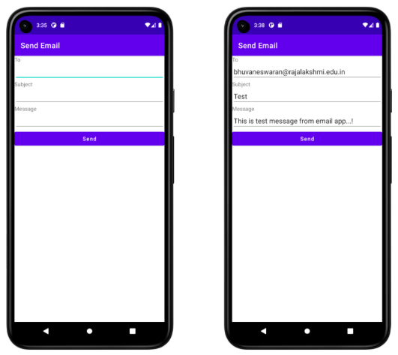

**Result:**

| The app successfully sends an email by using an Intent to launch the device's default email client, allowing the user to specify the recipient, subject, and message. |
| --- |